# Prototype Description

Description:

The technical solution implemented in our prototype is a web-based agricultural management system developed using Visual Studio (ASP.NET Web Application(.NET Framework)- WebForms). This solution provides a user-friendly interface and features separate portals for farmers and employees, facilitating efficient management of agricultural operations. The prototype offers the following capabilities:

Login and Authentication:

The system incorporates a secure login functionality where farmers and employees can authenticate themselves. Once logged in, they gain access to their respective portals, ensuring data privacy and authorized usage.

Employee Portal:

The employee portal enables employees to perform various tasks related to farmer management. Key features include:

View All Farmers: Employees can access a comprehensive list of all registered farmers, providing an overview of the farming community.

View Farmer's Products: Employees can review the products associated with a specific farmer, gaining insights into their offerings.

Add Farmer to Database: Employees have the ability to add new farmers to the system, facilitating the expansion of the farming network.

View Employee Details: Employees can access and review their own details, ensuring accurate information representation.

Farmer Portal:

The farmer portal empowers individual farmers to manage their agricultural activities effectively. Notable features include:

View Products: Farmers can easily navigate and view the list of products they have registered within the system, facilitating product management.

Add Product: Farmers have the ability to add new products to their inventory, enabling efficient tracking and showcasing of their offerings.

View and Edit Details: Farmers can access and modify their personal information, ensuring accurate and up-to-date records.

The Following Diagram helps show the navigation between Pages:

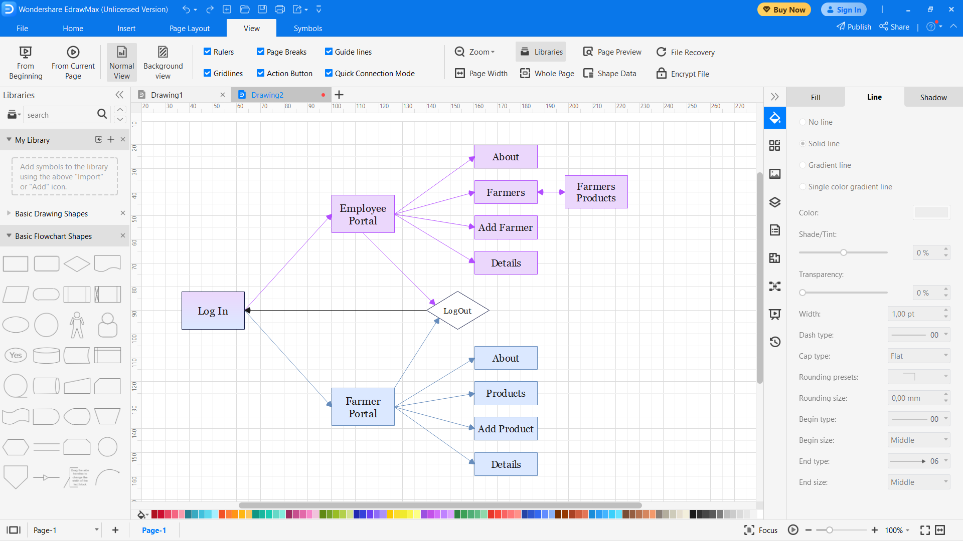

User Experience:

The entire web application is designed with a soft purple theme, creating a visually pleasing environment. The user interface focuses on simplicity and intuitiveness, ensuring a quick and easy user experience for both farmers and employees. This design approach enhances usability and encourages frequent usage of the system.

The Languages used in the prototype were C# for Back-end, HTML for from end and SQL for the database. The back-end and front-end code was accomplished using Visual Studio and the database system used was Azure Database as it is cheap and easy to use for a prototype. The frameworks utilized were a combination of the ITIL and TOGAF. A layered architecture and creational pattern were utilized to work between pages and data.

The following Diagram shows the Tables and fields relating that are in the Azure Database:

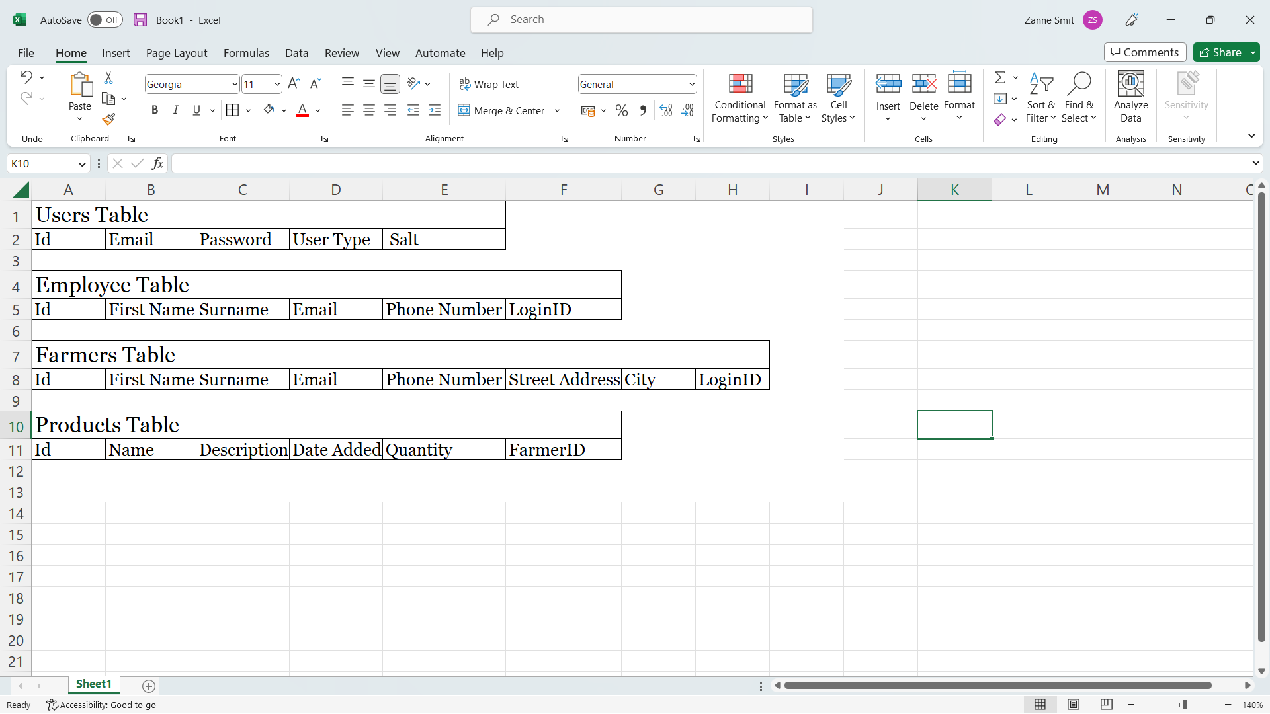

The technical solution implemented the prototype leverages Visual Studio to deliver a web-based agricultural management system that streamlines operations for farmers and employees. The system's user-friendly interface, combined with the soft purple theme and efficient functionality, contributes to a seamless and enjoyable experience throughout.